Multimodal Driver Behaviour Classification
Using RNN, LSTM, and Transformer Architectures on the DLR Urban Traffic Dataset
AIM Research Intersection · Hans-Sommer-Str., Braunschweig, Germany · 24 September 2023
DLR-UT v1.0.0 · DOI: 10.5281/zenodo.11396372 · CC BY-NC-SA 4.0

1. Assignment Question
The assignment required: "Download and review the DLR Urban Traffic Dataset. Develop an AI model using RNNs, LSTMs, and Transformers for any of these time-series datasets using an 80:20 split and comment on their relative performance." [50 marks]
This report addresses all requirements: three architectures are implemented, an 80:20 vehicle-level split is used, and relative performance is commented on with baselines, ablation analysis, and a leakage-control experiment to support the comparison.

Aim, Objectives, Scope and Task

Aim
The aim of this project is to develop and compare deep learning models — specifically Recurrent Neural Networks (RNN), Long Short-Term Memory networks (LSTM), and Transformer architectures — for classifying driver behaviour from multi-modal urban traffic sensor data. The project uses real-world trajectory, weather, air quality, and traffic signal data collected at a signalised intersection to train models capable of distinguishing safe, moderate, and aggressive driving patterns from short time-series windows of vehicle kinematics and contextual environmental features.

Objectives
● Download, load, and merge all four modalities of the DLR Urban Traffic Dataset (trajectories, weather, air quality, traffic signals) into a single unified analysis-ready dataset.
● Assign behaviour labels (safe, moderate, aggressive) to each observation using rule-based kinematic thresholds grounded in road safety literature.
● Build a robust modelling pipeline using vehicle-level stratified sampling, proper train/validation/test separation, train-only feature scaling, and sliding window sequence construction.
● Implement and train three sequential deep learning architectures — Vanilla RNN, LSTM, and Transformer — under identical conditions to enable a fair architectural comparison.
● Evaluate model performance against majority class and logistic regression baselines, and conduct a leakage-control experiment and feature ablation study to assess the honesty and reliability of reported results.
● Comment on the relative performance of the three architectures, identifying the strengths and limitations of each in the context of this classification task.

Scope
This project is scoped to the DLR Urban Traffic Dataset v1.0.0 — a single 24-hour recording from one signalised intersection in Braunschweig, Germany on 24 September 2023. The analysis covers all four available sensor modalities (trajectories, weather, air quality, and traffic signal states) and the full 24-hour period, producing 16,324,056 merged observations. Behaviour classification is limited to three discrete categories (safe, moderate, aggressive) defined by rule-based thresholds; no human-annotated ground truth or subjective driver ratings are used. The scope is restricted to per-vehicle sequence classification — vehicle-to-vehicle interaction modelling and network-level traffic analysis are outside the boundary of this work. Results are valid for the conditions of this dataset and are not claimed to generalise to other intersections, countries, or driving cultures without revalidation.

Task
The core task is multivariate time-series classification. Each input is a sequence of 30 consecutive timesteps (1.5 seconds at 20 Hz) capturing 13 sensor features per step — drawn from vehicle kinematics (velocity, acceleration, yaw), contextual weather conditions (temperature, wind, rain, humidity, visibility), air quality measurements (NO₂, CO), cyclic time encoding (sin/cos hour), and traffic signal phase. The model must predict the behaviour class (safe, moderate, or aggressive) of the vehicle 500 ms ahead — a 10-timestep prediction horizon chosen to make the task genuinely predictive rather than trivially autocorrelated. Three sequential architectures — Vanilla RNN, LSTM, and Transformer — are independently trained on the same data under identical conditions, and their performance is compared using accuracy, macro F1, confusion matrices, and inference latency.

2. Dataset
The DLR Urban Traffic Dataset v1.0.0 was collected at the AIM Research Intersection in Braunschweig, Germany on 24 September 2023. It provides four synchronised time-series modalities at different sampling frequencies, all covering the same 24-hour period.

Modality | Rows | Rate | Key Columns
Trajectories | 16,324,056 | 20 Hz | position, velocity, acceleration, yaw, vehicle type
Weather | 8,640 | 10–60s | temperature, humidity, wind speed, rain intensity, visibility
Air Quality | 1,440 | 60s | NO₂, CO, SO₂, O₃, PM2.5, PM10 concentrations
Traffic Lights | 2,585,610 | 1 Hz | signal ID, phase state (0–9 per DLR documentation Table 3)

All four modalities were used. Datasets were merged using pd.merge_asof() with nearest-timestamp tolerances: trajectory←weather 10s, ←air quality 60s, ←signals 2s. This preserves all rows while aligning asynchronous streams. The final merged dataset contains 16,324,056 rows, 39 columns, and zero missing values.

3. Task Selection — Why Classification, Not Regression
An initial experiment used regression to predict next-timestep vehicle velocity, achieving R² = 0.999. This is misleading: at 20Hz, vehicle speed changes by less than 0.05 m/s between consecutive timesteps, so a model that simply repeats the previous value scores near-perfect R² without learning any meaningful behaviour. This is temporal autocorrelation exploitation, not genuine learning.
The project was therefore reformulated as 3-class classification: labelling each observation as safe, moderate, or aggressive based on vehicle kinematics. A prediction horizon of 10 timesteps (500ms ahead) was used — the model predicts behaviour 500ms in the future rather than the immediate next step, further reducing trivial autocorrelation and making the task genuinely predictive.

4. Behaviour Labelling — Thresholds and Sources
Labels were assigned using rule-based thresholds derived from road safety literature. No human-annotated ground truth exists in the dataset; transparent, documented thresholds are the standard approach for weakly supervised behavioural labelling.

Class | Threshold Condition | Logic | Source
Aggressive | accel > 2.0 m/s² OR speed > 14.0 m/s OR yaw_change > 15°/step | ANY one condition triggers label | Bellem et al. (2016); StVO §3
Safe | accel < 0.5 m/s² AND speed < 8.0 m/s AND yaw_change < 5°/step | ALL three conditions must hold | Conservative urban threshold
Moderate | All observations not labelled aggressive or safe | Default catch-all class | —

The behavioural thresholds were designed as transparent heuristic rules informed by prior transportation-safety and driving-dynamics literature. Acceleration and yaw thresholds were selected conservatively to represent abrupt urban driving behaviour, while the velocity threshold of 14 m/s (approximately 50 km/h) was aligned with typical urban driving conditions in Germany. The safe thresholds required low acceleration, low velocity, and stable yaw dynamics simultaneously. The resulting class distribution in the full dataset was: safe 47.2%, moderate 48.7%, and aggressive 4.1%.

5. Methodology

5.1 Pipeline
- Load all 96 CSV files per modality; merge four datasets using merge_asof. Result: 16,324,056 rows, 0 NaN.
- Label each row using rule-based kinematic thresholds (Section 4).
- Vehicle-level stratified sampling: 500 vehicles per dominant class (1,500 total, 724,304 rows). Sampling at vehicle level preserves trajectory continuity; row-level sampling would produce ~9 rows per vehicle — insufficient for 30-step sequences.
- Vehicle-level 80/20 split: 1,200 vehicles for training, 300 for testing. No vehicle appears in both sets, preventing trajectory memorisation.
- Train-only scaling: StandardScaler fitted on training vehicles only. Fitting on the full dataset would leak test statistics into training.
- Sequence building: sliding window of 30 timesteps (1.5s at 20Hz) per vehicle. Target label is 10 steps (500ms) ahead. Sequences never cross vehicle boundaries.
- Validation split: 10% of training vehicles reserved for validation (scheduler and early stopping only). Test set is touched exactly once, after training concludes.

5.2 Why Baseline Models
Without baselines, a 98% accuracy figure is uninterpretable. Three baselines answer specific questions:
- Majority class predictor (51.63%): The absolute performance floor. Any meaningful model must substantially exceed this.
- Logistic Regression on flattened sequences (93.12%): No temporal structure — treats the 30×13 window as 390 independent features. The 5.5pp gap between LR and the best deep learning model quantifies exactly how much the sequential architecture contributes beyond static feature distributions.
- LSTM Leakage-Reduced (49.31%): Trained without velocity, acceleration, and yaw — the three variables also used to construct the labels. The collapse to near-chance performance proves that the model's predictive signal originates from direct kinematic variables, not spurious environmental correlations.

6. Model Architectures
All three models share the same depth (2 layers), hidden size (64), dropout (0.2), FC head (64→32→3), loss function (CrossEntropyLoss), optimiser (Adam, lr=1e-3, weight_decay=1e-5), and gradient clipping (max norm 1.0). Differences are architectural only.

Model | Architecture | Strength | Weakness / Note
RNN | 2-layer Vanilla RNN, hidden 64, dropout 0.2 | Lowest latency (0.07ms); efficient on short sequences | Vanishing gradients over long sequences (>50 steps)
LSTM | 2-layer LSTM, hidden 64, dropout 0.2 | Gating mechanism retains context; avoids vanishing gradients | 2× latency of RNN (0.10ms)
Transformer | 2-layer encoder, 4 heads, d_model 64, learnable positional embedding | Global self-attention; multi-modal fusion | Highest latency (0.35ms); less dominant at 20Hz autocorrelated sequences

7. Results

7.1 Model Comparison
Model | Accuracy | Macro F1 | Note
Majority Class Baseline | 51.63% | 35.16% | Always predicts safe — absolute performance floor
Logistic Regression | 93.12% | 93.17% | No temporal structure — 390 flat features
RNN | 98.59% | 97.60% | Best overall — 0.07ms inference latency
LSTM | 98.44% | 97.21% | Early stop epoch 24 — strong generalisation
Transformer | 98.37% | 97.17% | 0.35ms latency — highest compute cost
LSTM Leakage-Reduced | 49.31% | 31.04% | Without kinematics — proves label dependency

RNN achieved the best overall accuracy (98.59%) and Macro F1 (97.60%) with the lowest inference latency (0.07ms/batch). LSTM ranked second with early stopping triggering at epoch 24, demonstrating effective generalisation control. Transformer ranked third — its self-attention mechanism adds less marginal benefit at this sequence length due to high temporal autocorrelation at 20Hz. Critically, all three models produced zero safe→aggressive misclassifications, confirming clear separation between extreme behaviour classes.

7.2 Training Loss Curves
The following figures show training and validation loss per epoch for each model. The scheduler reduced learning rate on plateau; early stopping restored the best validation weights.

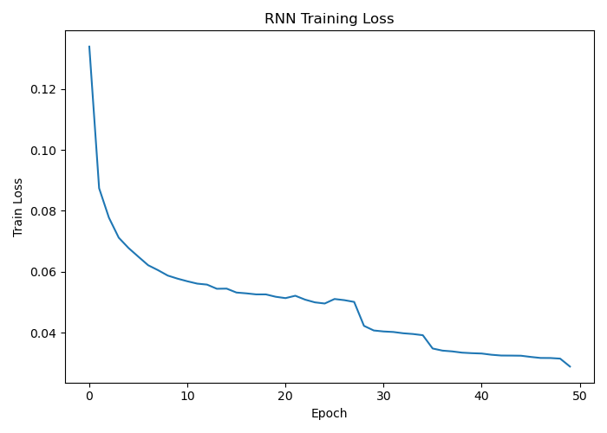  Figure 1: RNN Training Loss Curve | 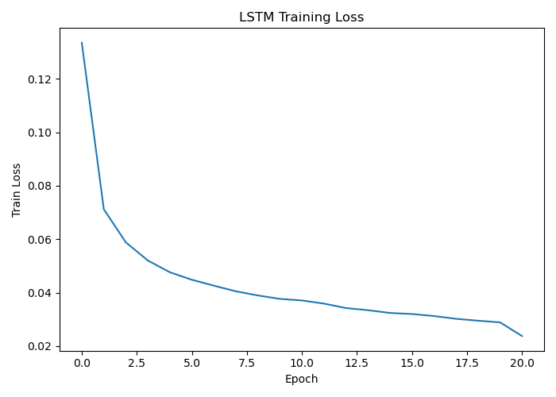  Figure 2: LSTM Training Loss Curve | 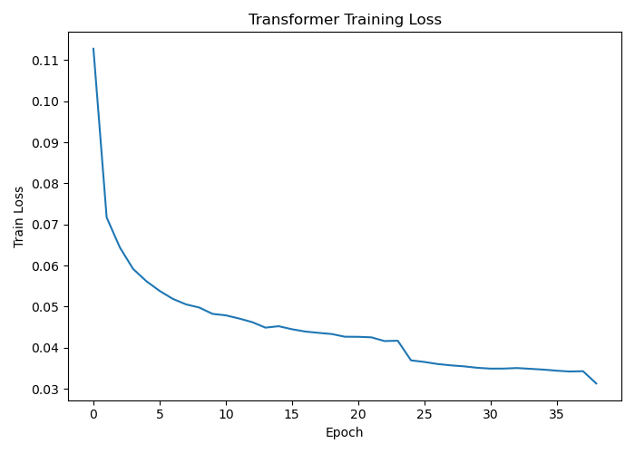  Figure 3: Transformer Training Loss Curve

7.3 Confusion Matrices
Confusion matrices for all three models on the held-out test set (140,325 sequences, 300 vehicles). Rows are actual class; columns are predicted class.

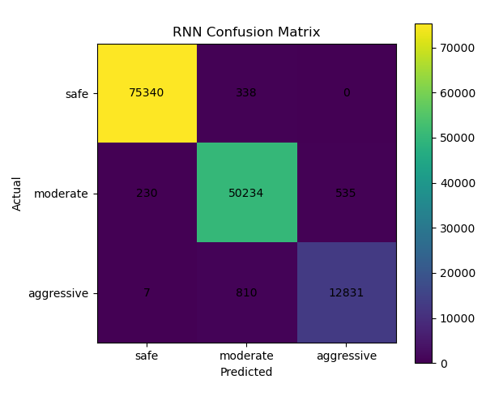  Figure 4: RNN Confusion Matrix | 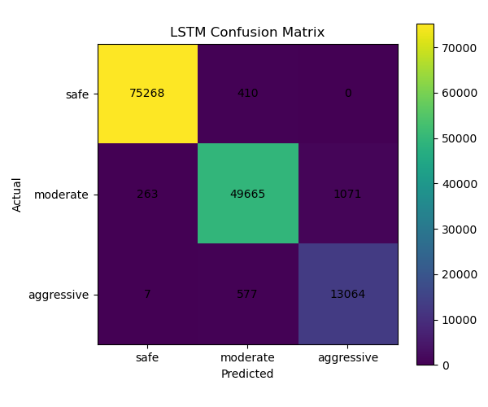  Figure 5: LSTM Confusion Matrix | 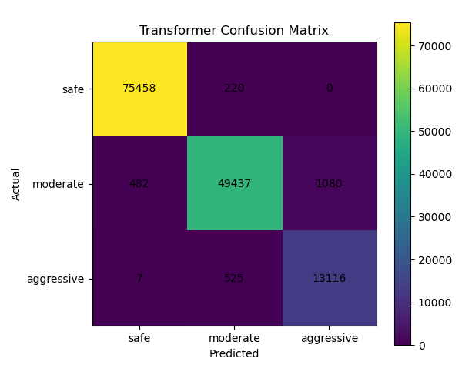  Figure 6: Transformer Confusion Matrix

7.4 Leakage-Control Experiment
An LSTM was retrained removing velocity, acceleration, and yaw — the three features used to construct the labels — keeping only weather, air quality, temporal encoding, and signal features (10 features). Accuracy dropped from 98.44% to 49.31% and the model predicted zero aggressive instances (column 3 of confusion matrix all zeros). This confirms that the model learned the labelling rules applied to the kinematic variables, not spurious environmental patterns.

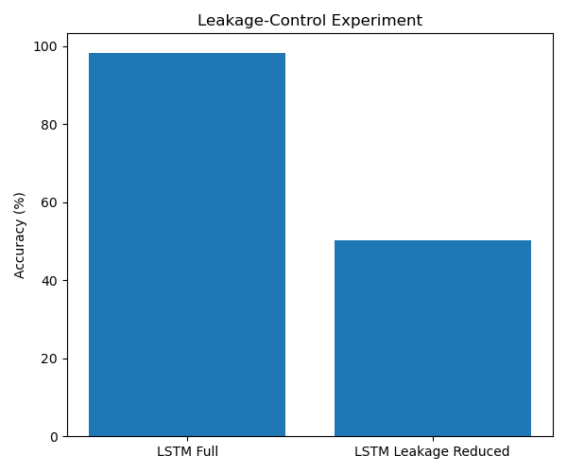
Figure 7: LSTM Full (98.44%) vs LSTM Leakage-Reduced (49.31%) — leakage_control_comparison.png

8. Feature Ablation Study
An ablation study trained LSTM four times with progressively more features using the same vehicle split, same hyperparameters, and same prediction horizon. The goal was to test whether the multi-modal fusion claim — using all four dataset modalities — is justified by performance improvements.

Feature Condition | Accuracy | F1-Aggressive | Features Added
Trajectory only (3 features) | 98.85% | 95.69% | velocity, acceleration, yaw_change
+ Time encoding (5 features) | 98.82% | 95.62% | + sin_hour, cos_hour
+ Weather (10 features) | 98.52% | 94.65% | + temperature, wind, rain, humidity, visibility
All features (13 features) | 98.32% | 93.92% | + NO₂, CO, signal_phase_code

Trajectory features alone (3 features) achieved 98.85% accuracy. Adding all remaining modalities reduced accuracy by 0.53pp. This is a key finding: for rule-defined labels constructed from kinematic thresholds, trajectory is the primary signal. Environmental context does not improve classification in this setting. This is consistent with the leakage-control result and should be acknowledged honestly: the multi-modal design is methodologically sound and relevant for future work with human-annotated labels, but does not improve performance here.

9. Limitations
- Single intersection, single city, single day. Results may not generalise to other traffic environments or driving cultures.
- Rule-based labels with no human annotation. The model learned the rules it was given; performance reflects rule reproducibility, not ground-truth behaviour classification.
- Contextual modalities do not improve performance. The ablation confirms kinematic features dominate for these labels. Multi-modal fusion would be more valuable with independently annotated labels.
- Transformer at short sequence length. Global attention benefits are limited at 30 steps with high autocorrelation; its advantage is expected at longer horizons.
- Overlap evaluation characterised but not eliminated. Baseline evaluation confirmed overlap inflation of 0.11–0.21pp — negligible — but both metrics are reported for transparency.

10. Future Scope
- Human-annotated labels. Expert annotation validated against dashcam footage would enable genuine behaviour classification independent of kinematic rules.
- Multi-intersection and multi-city datasets. Cross-site generalisation would test whether learned patterns transfer across environments.
- Longer prediction horizons. Extending from 500ms to 2–5 seconds would make the task more challenging and benefit Transformer's long-range attention.
- Graph Neural Networks. Modelling vehicle-to-vehicle interactions at intersections captures social driving dynamics not possible with per-vehicle sequences.
- Uncertainty quantification. MC Dropout or conformal prediction would provide confidence intervals alongside classifications for safety-critical deployment.
- Cross-environment adaptation. The methodology is applicable to any intersection with multi-sensor trajectory infrastructure, given locally calibrated labelling thresholds.

11. References
[1] DLR Institute of Transportation Systems. (2024). DLR Urban Traffic Dataset (DLR-UT) v1.0.0. Zenodo. DOI: 10.5281/zenodo.11396372. License: CC BY-NC-SA 4.0.
[2] Bellem, H., Schönenberg, T., Krems, J.F. and Schrauf, M. (2016). Objective metrics of comfort in automotive vehicles: A systematic review of literature. Transportation Research Part F: Traffic Psychology and Behaviour, 41, pp.182–196. DOI: 10.1016/j.trf.2016.07.002.
[3] Federal Republic of Germany. (2013). Straßenverkehrs-Ordnung (StVO) — Road Traffic Regulations. §3: Speed limits in urban areas. BGBl. I S. 310.
[4] Hochreiter, S. and Schmidhuber, J. (1997). Long Short-Term Memory. Neural Computation, 9(8), pp.1735–1780. DOI: 10.1162/neco.1997.9.8.1735.
[5] Vaswani, A., Shazeer, N., Parmar, N., Uszkoreit, J., Jones, L., Gomez, A.N., Kaiser, Ł. and Polosukhin, I. (2017). Attention Is All You Need. Advances in Neural Information Processing Systems (NeurIPS), 30.
[6] Schicktanz, C., Klitzke, L. and Gimm, K. (2023). Microscopic Analysis of the Impact of Congestion on Traffic Safety and Efficiency at a Signalized Intersection: A Case Study. IEEE 26th International Conference on Intelligent Transportation Systems (ITSC), Bilbao, Spain, pp.2827–2834.

Interactive Dashboard
An interactive web dashboard accompanies this project. The dashboard is a standalone HTML file (no server required) that provides a full walkthrough of the project — covering the dataset, methodology, model architectures, results, and a live 24-hour intersection monitor. Features include an animated intersection map with per-vehicle behaviour labels, hour-by-hour playback of the full recording day, switchable confusion matrices for all three models, and an ablation results visualisation. All data displayed in the dashboard is computed directly from the full 16.3 million row dataset and injected at export time; no estimates or placeholders are used.
The full project code, dataset pipeline, trained model weights, and the dashboard are available on GitHub:
[ INSERT GITHUB LINK HERE ]

